Making Payments outside the United States & all countries not using the US Dollar:

- Note: Please make payments to Brand Marketing Services, Inc., (doing business as Brands That Deliver™).
- If outside the US please pay in US Currency ONLY.

If using PayPal outside of the US
- Open up a browser and go to your PayPal account and log in. (Do not pay via the BrandsThatDeliver.com website.)
- When selecting payments, please select US Currency and pay the agreed-upon amount in US Dollars. Thank you!
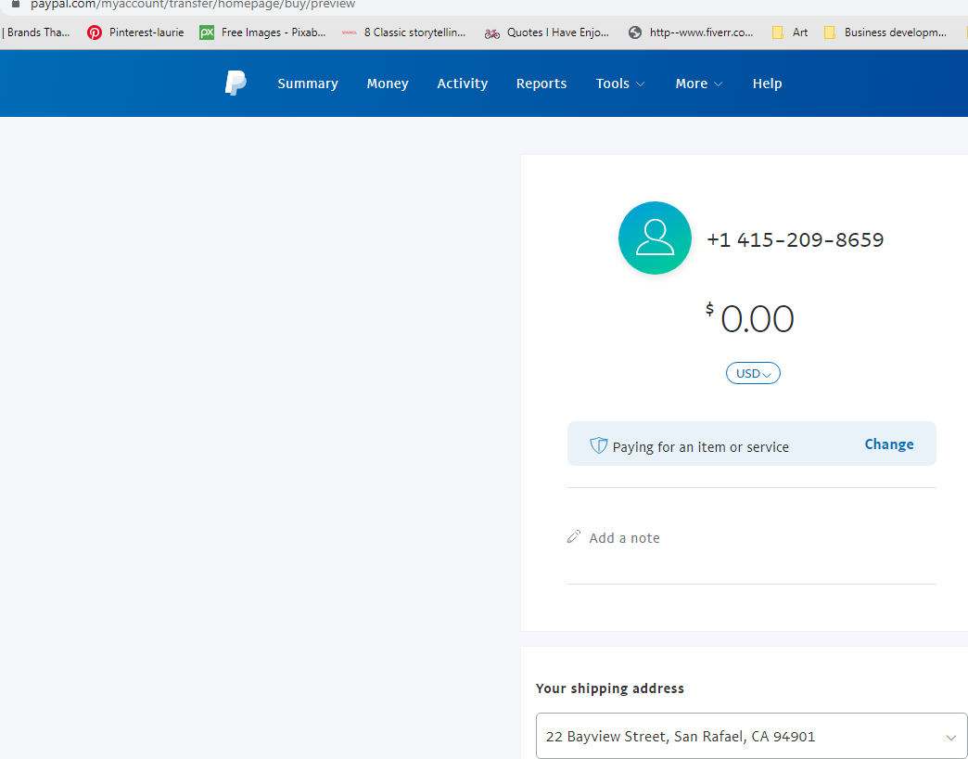

For any questions and any other method of payment,
please contact Laurie Rinker

lrinker@BrandsThatDeliver.com
415.209.8659

